JOHN & FERNANDA RENO IN BRAZIL
MARK.1:38; ¨And He said unto them, Let us go into the next towns, that I may preach there also; for therefore came I forth.¨

February, 2023

Dear Friends and Supporters,
Thank you so much for your praying for us this month. We have had a lot of sickness around us and some in our family, but we were never all sick, and so were able to keep on ministering. As I mentioned last month, January is also a time for planning the first 7 months of the year, and we are excited to see what the Lord will let us do this year.
We are continuing the services in Big Yard every two weeks on Saturday nights. The Lord is still working and is bringing people regularly. We are delighted to see this progress. We had no evangelistic meetings in January, but we are scheduled with a week starting the 6th of February.
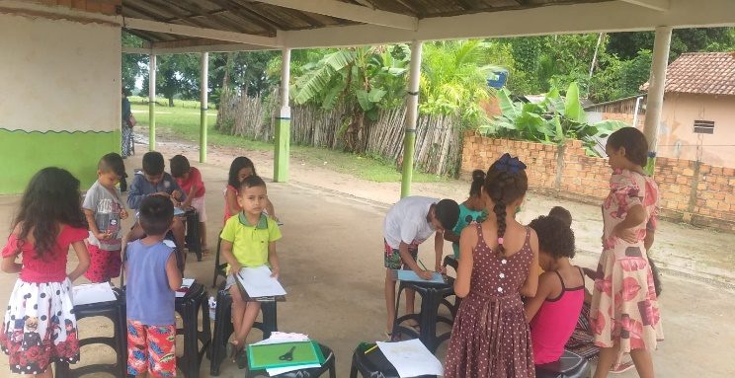
We asked last month that you pray for the teachers that we are training to teach in Sunday School in Liberty. Thankfully, they seem to be continuing well, and they are working to grow their class. The goal is to split it into age groups after a certain size, and we have already started dividing it for the activity time. Pray that the teachers would continue to grow spiritually.
One of the benefits of living where we work is that our children go to school with the children of the village. They are taking advantage of inviting children to Sunday School and services. Also, Deborah is doing quite a few projects in school. The mothers get together as well. Fernanda has had several chances to explain how we are different and what we believe. Please pray for the families connected with the children that our children know.
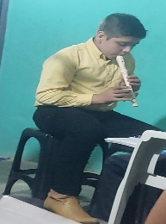
I mentioned last month that Bobby has started on the recorder with others from the group here. He has done special music several times and is enjoying practicing and learning. The girls also are learning, but prefer singing for special music right now.
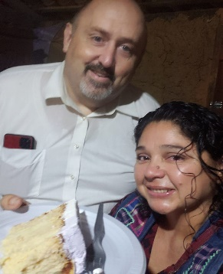
Earlier on in the month, a lady from our group had her birthday. We as a family were invited to their house for a piece of cake after the service. Brazilian tradition is that the first piece of cake goes to the honored person for a reason that may or may not be stated. The piece was given to “the couple that showed me the true Way, Jesus Christ.” This was a huge encouragement to Fernanda and I.
It is wonderful for the missionary to see God answering prayer. It encourages him or her in the moments of tribulation. But, beyond that, is being privileged to be able to observe the young Christian see that God answers prayers. This month we had the privilege to see spiritual children see and recognize that God is specifically answering their prayers.
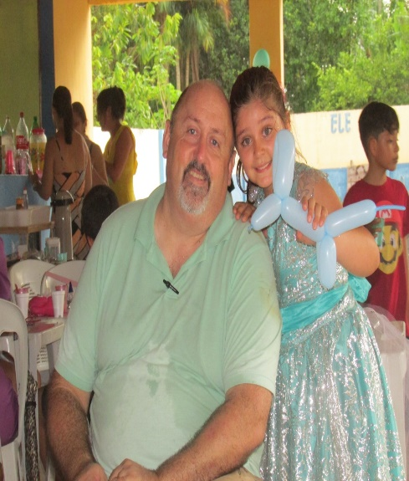
January is Deborah´s birthday month. At 10, we try to have a party for our children. We chose a time of playing together with minimum food compared to traditional parties here. It went well. We are in rainy season since mid December, and it is raining almost every afternoon. At the prayer meeting before the party, the group had a burden to pray for no rain. I had not thought to initiate such, but they did. The Lord honored in that there was no rain the day before and only sprinkles the day of.
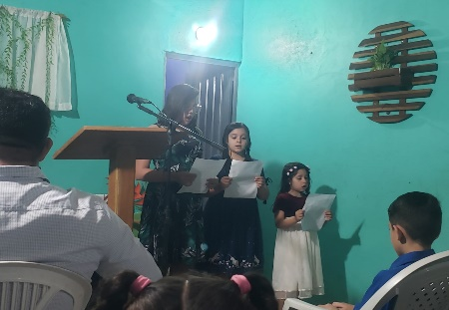
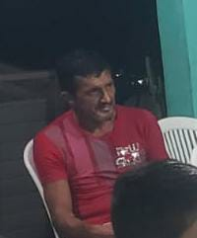
For some time, I have prayed for and witnessed to the town drunk. At the above mentioned prayer meeting I was teaching on praying for someone and putting that in practice by inviting them. At that moment, he walked by in the street, and I shared how God had burdened my heart for him. By next Sunday, two others had invited him as well, and he shocked many by appearing for the first time in our service. He didn´t stay the whole service, but the group saw that God answers prayers.
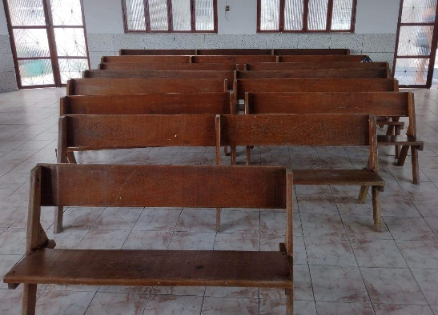
For some time, the group in Sao Luis has been praying that God would provide a larger place for us to meet. Until now, we have met on our front porch, which can work for 15 to 25 people. We are having right around 15 regularly and have had as many as we have space for some times. We have reached the point that people hesitate to come because of lack of space. It has been a weekly request for a bigger space. Recently, we were given church benches, which would not be optimum on our porch, but are what we will need in a bigger space. As we rejoiced in the gift, we realized that God would not provide benches so far ahead of the space for which we have prayed. As a group, we are praying even harder that God would give us the larger space that we have requested.
Thanks so much for praying for us. Please continue to join in with us in the battle for souls.

In His Service,
John, Fernanda + 3

